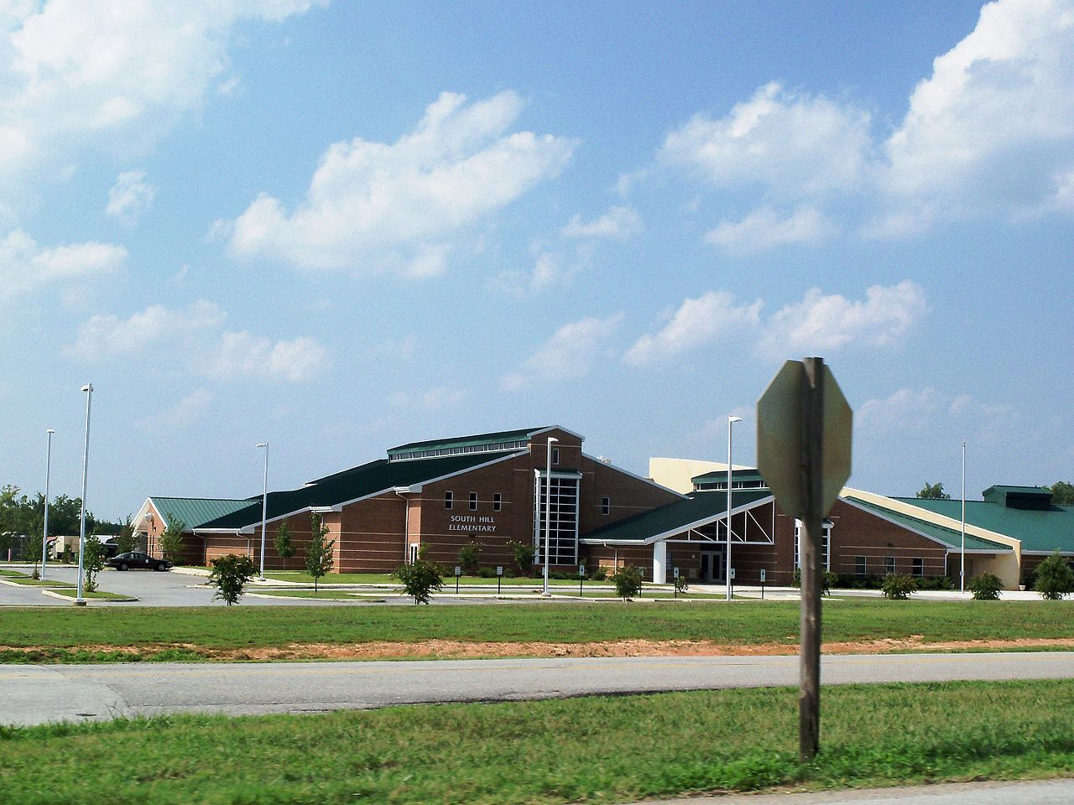

MINIMUM CAPACITY :-
The Minumum intake capacity
of students is between 920-1020
children

LIBRARY :-
The Libarary is Available.

CANTEEN:-
The Canteen Facility is Available.

BOARDING :-
No availablility of boarding.

SPORTS :-
There are different categories
sports available.
Girls Volleyball
Boys Volleyball
Football

SOUTH HILL ELEMENTARY SCHOOL
ITHACA - SCHOOL

School Detail :-
South Hill Elementary is a public school located in South Hill, VA, which is in a fringe rural setting. The student population of South Hill Elementary is 724 and the school serves PK-5. At South Hill Elementary, 93% of students scored at or above the proficient level for math, and 78% scored at or above that level for reading.

